



ADVANCED SPREADSHEET APPLICATIONS
(235)
NATIONAL 2021

Production:
Job 1: Advanced Formulas __________ (85 points)
Job 2: Conditional Formatting __________ (95 points)
Job 3: What-If Analysis __________ (150 points)
TOTAL POINTS __________ (330 points)

Test Time: 90 minutes

GENERAL GUIDELINES:
Failure to adhere to any of the following rules will result in disqualification:
- Contestant must hand in this test booklet and all printouts if any. Failure to do so will result in disqualification.
- No equipment, supplies, or materials other than those specified for this event are allowed in the testing area. No previous BPA tests and/or sample tests (handwritten, photocopied, or keyed) are allowed in the testing area.
- Electronic devices will be monitored according to ACT standards.

INSTRUCTIONS:
- Key your contestant number and printout number in the right section of a footer on each printout on a separate line in the footer. Your name or initials should not appear on any work you submit.

- Center the following information in a header on each printout: File name and the sheet name. Each item should appear on a separate line in the header.
- If you finish before the end of the testing time, notify the proctor. Time may be a factor in determining the winner in the event of a tie.

- When turning in your contest, arrange all jobs in the correct printout order (included in instructions).

- Write your contestant number in the provided spaces on the test cover page.

GRADER: points are all or none unless otherwise noted!

Job 1 (Advanced Formulas) | Points Possible | Points Earned
Contestant # and Job # in right section of footer | 10
File name and sheet name in the header | 10
B3:G14 and I3:N14 on the Sales sheet are Accounting number format | 5
B5:M7 on the Breakdown sheet are Accounting number format | 5
B5:M5 on the Breakdown sheet filled with number of Tokens sold from Sales sheet | 10
B6:M6 on the Breakdown sheet filled with Ticket sales from Tablet 1-6 for each day | 15
B7:M7 on the Breakdown sheet filled with daily total of Other Sales | 15
Landscape Orientation | 5
Print Data and Print Formulas | 10
Subtotal | 85
Job 2 (Conditional Formatting) | Points Possible | Points Earned
Contestant # and Job # in right section of footer | 10
File name and sheet name in the header | 10
Breakdown Sheet: Top 10 items filled with Green Fill with Dark Green Text | 10
Breakdown Sheet: Cells less than $400 are filled with Light Red | 10
Correct formulas in B10 using range name | 10
Correct formula in B11 using range name | 10
Correct formula in B12 using range name | 10
B10:B12 formatted to Accounting number format | 5
Columns are resized so no data is cut off | 5
Breakdown sheet is printed | 5
Print Area is set to include only cells A3:B12 | 5
Breakdown sheet Formulas are printed | 5
Subtotal | 95
Job 3 (What-If Analysis) | Points Possible | Points Earned
Contestant # and Job # in right section of footer | 10
File name and sheet name in the header | 10
B3 is updated to 60% | 5
60% Adult Scenario is created | 20
70% Adult Scenario is created | 20
80% Adult Scenario is created | 20
90% Adult Scenario is created | 20
100% Adult Scenario is created | 20
Scenario Summary Sheet is created | 20
Landscape Orientation | 5
Subtotal | 150
TOTAL POINTS | 330

Job 1 – Advanced Formulas (Printout #1) 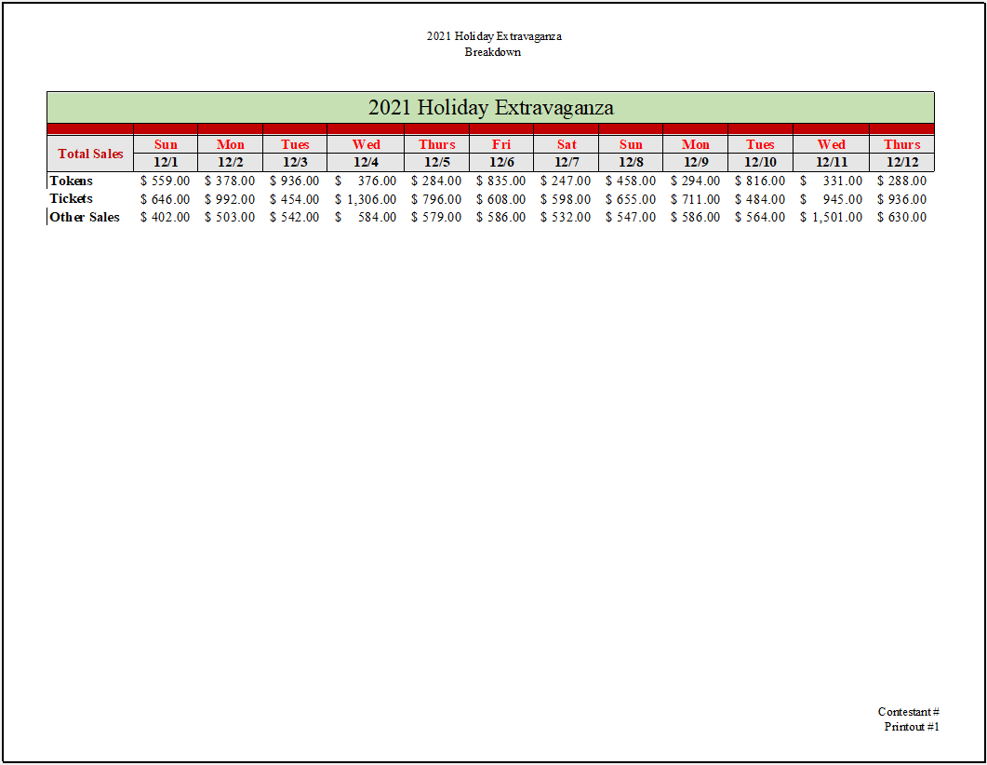
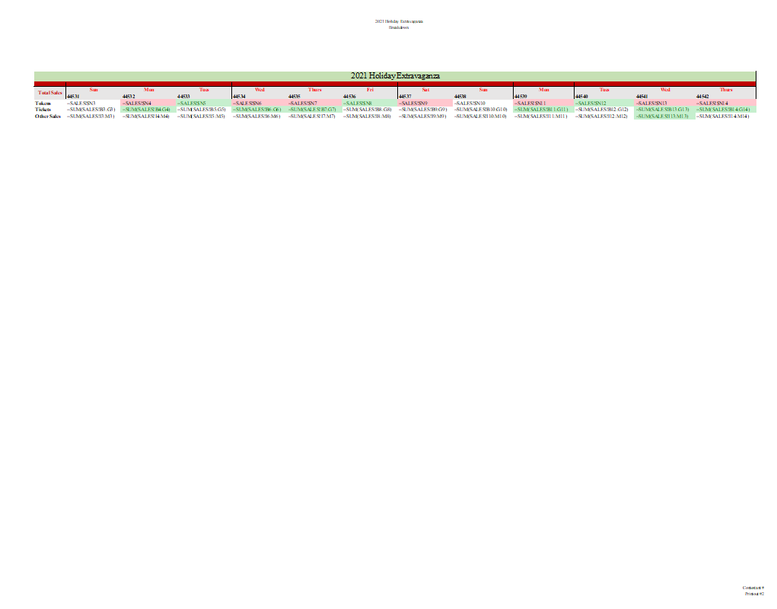
Job 1 – Advanced Formulas (Printout #2)

Job 2 – Conditional Formatting (Printout #1)
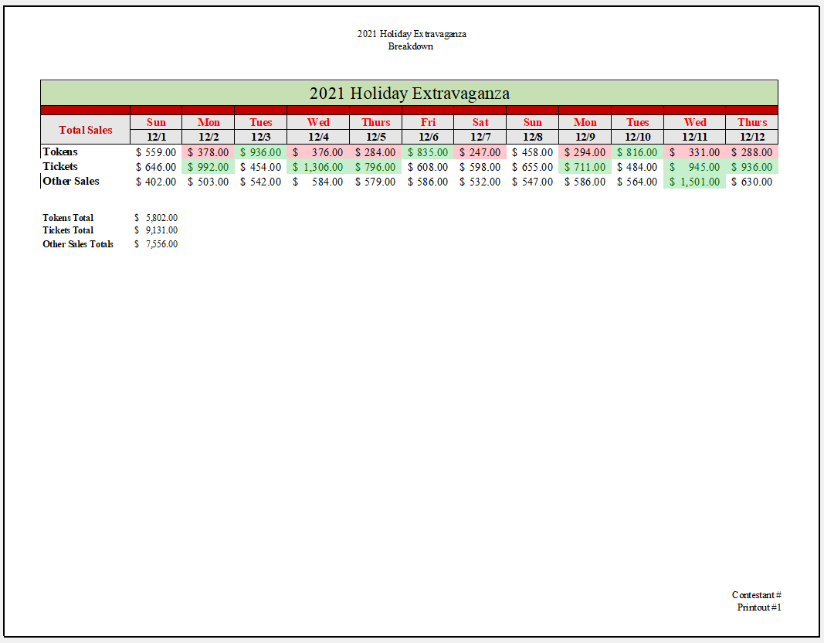
Job 2 – Conditional Formatting (Printout #2)
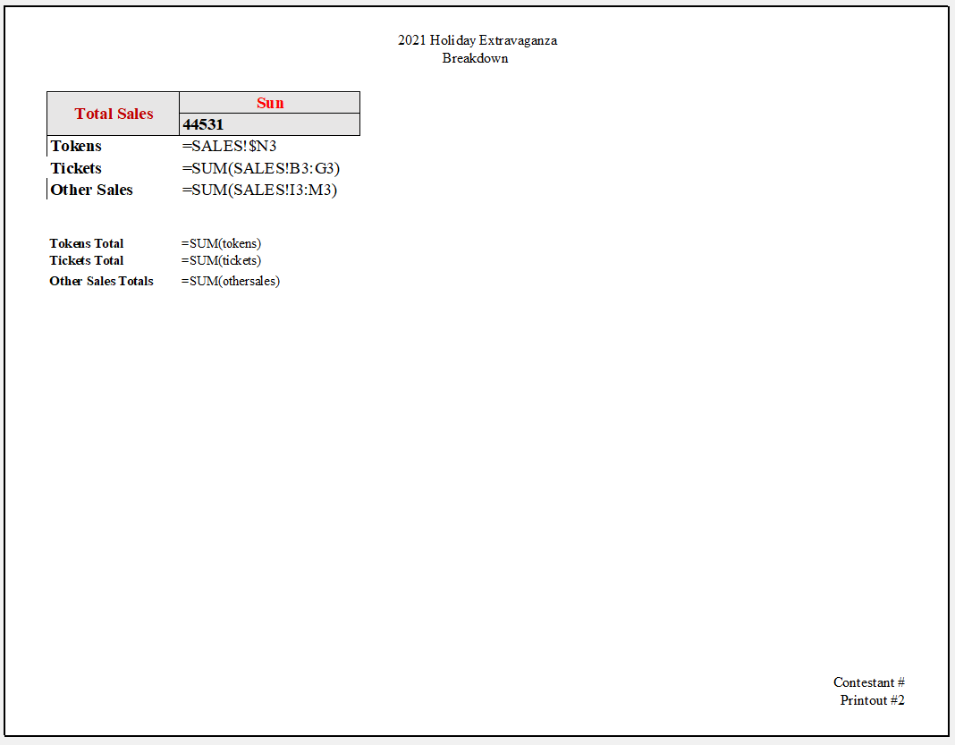
Job 3 – What-If Analysis
